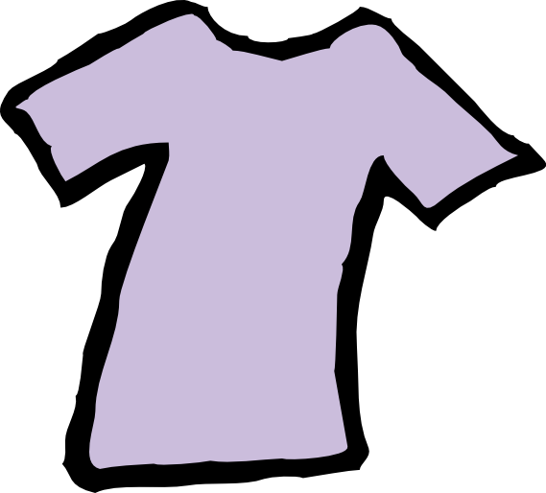Andy’s Closet 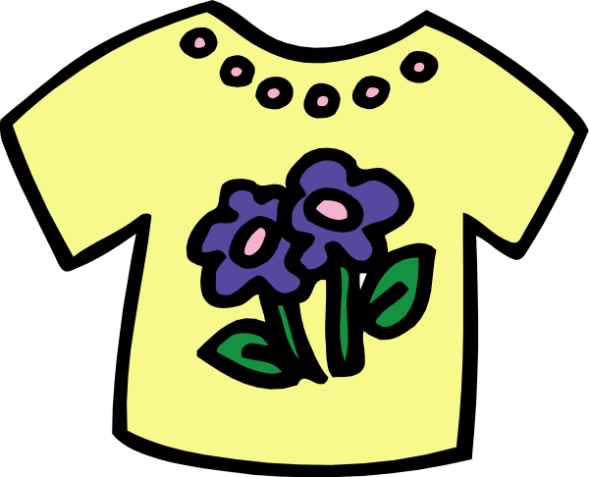
Clothing Request Form

Name of person the order is for: | Date of order:

Male: | Female: | Age:

Name to be notified: | Date filled: _______________________

Request made by (ex. School, Agency, Individual, etc.)
______________________________________________________________________________________________

Number of order (Andy’s Closet Staff): ____________________

Male: | Female: | Age:

We will do our best at Andy’s Closet to get you all of the clothing that you need for the season we are in. Please know that we are a charity and 100% of our clothing comes from donations and sometimes we run low.

Special Requests: Please list below any special requests you may have. We would appreciate anything you can tell us about your style, color preferences, or types of clothing you prefer to help us pick out clothing you would like to wear.

Please include the size when checking an item of clothing needed.
(ex. girls size 12, women’s small, men’s medium, XL, etc.)

Winter coat: | Light Jacket: | Dresses: | Skirts:
Sweatshirts: | Sweaters: | PJ’s:
Long Sleeve: | Short Sleeve: | Tank Tops:
Sweatpants: | Jeans: | Pants: | Shorts:
Sneakers: | Boots: | Shoes:
Gloves: | Hats: | Backpack: | Belt:
Underwear size: |  | Sock size:
______________________________________________________________________________________________

Bottom portion to be filled out by Andy’s Closet staff Number of order: __________________

Gender: ______ Sizes: _____________ Socks included:__________ Underwear included: _________ Andy’s Closet Member: ________________________________________________ Date filled: _________________

