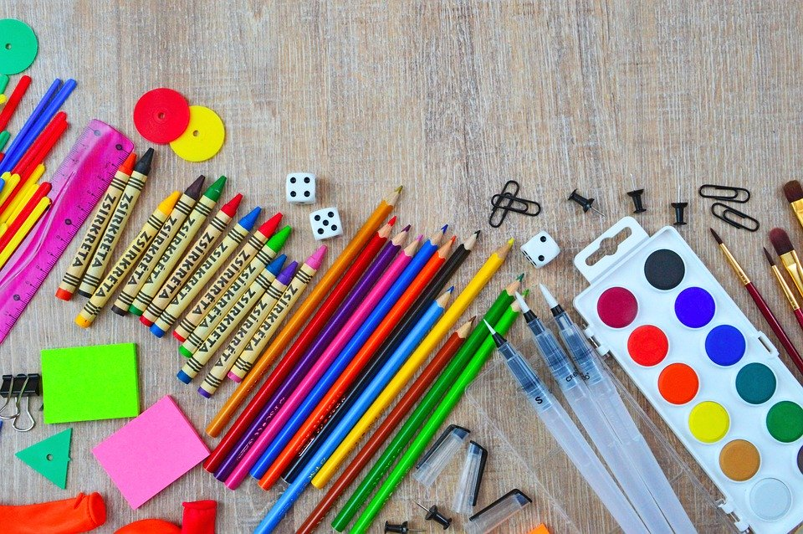
6 Yellow Supply List 2020-2021
- Clipboard
- Small brown paper bags or plastic bag, labeled with student name for mask storage
- Headphones with microphone (in plastic ziploc bag, labeled with sharpie on bag and headphones)
- Washable pencil case
- Extra masks
- Glue sticks
- Highlighters
- Sticky notes
- Scissors
- Pencils
- Personal pencil sharpener
- Colored pencils
- Colored markers
- 8 colored watercolor paint set
- Sharpie
- Stylus
- Personal Whiteboard
- Dry erase markers and eraser
- Plenty of personal packs of tissues
- One small single subject journal for morning meeting/advisory

ELA/SS
- One 3-subject spiral notebook with pockets
- Sturdy folder with pockets 1-2 (we will start with one and have a replacement if needed)
- Index cards

Math/Science
- One 3-subject spiral notebooks with pockets
- Sturdy folder with pockets (2)
- Composition notebook (science)

