5-White Supply List
2019-2020
*Please be sure to label your materials with your first and last name, and 5-White! Also, be sure to bring in a filled water bottle each day labeled with your name as water fountains will not be open.

For yourself in a hard pencil case:  - Box of 20 pencils (regular or mechanical)  - Erasers  - Small pencil sharpener (can hold shavings)  - Markers  - Colored Pencils  - Sharpie  - Glue stick  - Scissors | 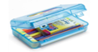
For your safety:  - Extra Mask (gators and bandanas are not allowed)  - A new ziplock baggie each day for your mask when removed (labeled with your name)  - Small package of tissues for personal use  - (Optional) Mask lanyard | 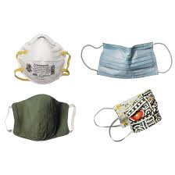
For your work:
- 5 plastic pocket folders (Red, Orange, Yellow, Blue, Green)
- 2 single-subject notebooks
- Clipboard
For your iPad work:
- (Optional) Inexpensive stylus
- Inexpensive ear buds/headphones
For our classroom:
- 1 box of tissues

