5-White Supply List
2018-2019

For your portfolio:  - 2” white (with a view) 3-ring binder | 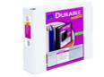
For yourself in a ziplock bag  - Box of 20 pencils  - Erasers  - Small pencil sharpener | 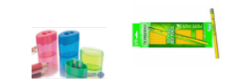
For yourself for the year  - I small pencil box filled with  - Markers  - Colored Pencils  - Glue stick  - Scissors | 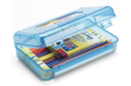
For your work  - 5 plastic pocket folders (Red, Orange, Yellow, Blue, Green  - 3 single-subject notebooks | 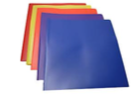
For your iPad work  - Inexpensive stylus  - Inexpensive ear buds/headphones | 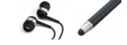
For carrying your belongings  - Plastic crate/bin 12 quart or larger | 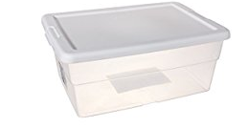
For our classroom  - 1 roll of paper towels OR  - 1 box of tissues | 