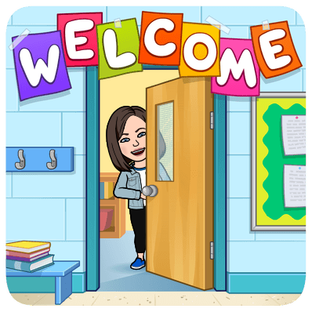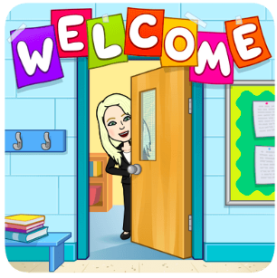

WELCOME TO THE 5 TEAL TEAM!

Mrs. Martin, English Language Arts and Social Studies Teacher
Mrs. McCarthy, Mathematics and Science Teacher

Dear 5 Teal Students,

Welcome! This school year, we know you will develop an excellent team spirit and show pride in your team, and in your work. Your positive attitude, and active participation, are important for a successful year.

We will work on creating an environment where you feel safe and where a respectful community is our #1 goal. Coming to school with a sense of personal responsibility will allow you to do your best. It’s going to be a great year on 5 Teal ☺

A Few Friendly Reminders:

- Please wear your team color, TEAL, on the first day of school. All 5th graders will gather in the Gym and find the teachers holding signs that say “5 Teal.”

- It will be helpful if you know which homeroom you are in:
- Mrs. McCarthy room 329
- Mrs. Martin room 327
- If you don’t know your homeroom, NO WORRIES! We have a list and will let you know

- Please bring a SSR (sustained silent reading) book to school on your first day. Every day at Sherwood during dismissal the whole school participates in silent reading. Don’t forget to bring a good book!

- Finally, below you will find a list of school supplies. Please do your best to have these supplies during the first day of school.

We are looking forward to meeting everyone on Wednesday, September 1st!
Sincerely,
Mrs. McCarthy - vmccarthy@shrewsbury.k12.ma.us
Mrs. Martin - memartin@shrewsbury.k12.ma.us
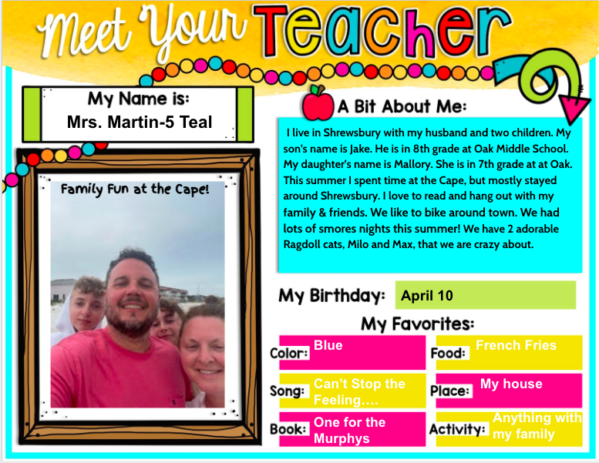

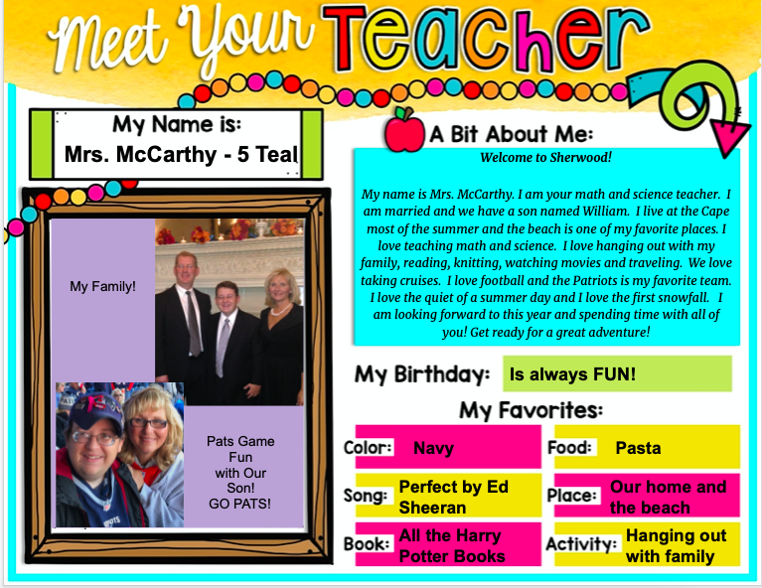
5 Teal Supply List 2021-2022

When you return to school on SEPTEMBER 1st we ask that you
have the following materials with you:

Quantity | Item | √
1 | 1½ inch 3 – ring binder (Color – Black) and a pack of 8 dividers for Math and Science (please NO zipper binders – these do not fit in the desks)
1 | pack of lined paper, with holes for binder
4 | sturdy two pocket folders; 1 yellow, 1 red, 1 blue, 1 purple (Math/Sci)
2 | Sturdy two pocket folders; Any colors (ELA/SS)
2 | glue sticks
1 | box of pencils
2 | Black Sharpies (fine or ultra- fine point)
1 | Package of multi-color highlighters
1 | small handheld pencil sharpener
1 | stylus for the iPad
1 | earbuds to use with iPad that can be kept in pencil case
1 | package of red pens
2 | boxes of colored pencils
1 | soft zippered pencil pouch
1 | pair of scissors
1 | box of tissues
1 | roll of paper towels
1 | Box of gallon ziplock bags
 | Optional donations: Hand sanitizer, Greenworks cleaning wipes

