Thinking Classrooms

“Thinking Classrooms” is a new pilot program at Shrewsbury High School that reimagines learning space in math classrooms. It has been met with great success in other classrooms across the state and the country. The proposal for the program came from Jean Marie Johnson, a math teacher at SHS, and other co-workers, after reading Peter Liljedahl’s book "Building Thinking Classrooms”. They were particularly inspired by Mr. Liljedahl’s statement, “When students are sitting, they feel anonymous. And when students feel anonymous, they are more likely to disengage. … When students get into their groups and start working on vertical surfaces, the skills they need to be successful are things like communication, perseverance, patience, self-reliance, et cetera. … In a culture that values thinking - as opposed to answers - there is no motivation to just get the answer. It is the thinking that matters.”

According to Ms. Johnson, “The idea is to create vertical, non-permanent surfaces in our classrooms to encourage students to work with their groups, persevere longer when working on problems without teacher assistance, and to try out ideas and experience the thinking process as nonlinear and sometimes messy. …Designing some of our math classrooms in this way, is aligned with our strategic priority of creating spaces and resources to support effective learning, as well as creating learning environments where everyone’s success matters.”

The Colonial Fund has funded a total of 35 white boards mounted across 7 classrooms, helping to create those vertical, non-permanent work surfaces where students can work through math problems in small groups.

Over April vacation, the first math classroom was outfitted with 5 new white boards. The remaining white boards will be installed in the other 6 classrooms this summer.

So, how do the students like it? Teacher Ms. Johnson has observed, “…students like having the space to work together and understand how communicating with each other about their works is beneficial for the student who is writing on the board and for the student who may be confused. They are able to be more active in the classroom and move around instead of being confined to their seats … students are appreciating the need to be a good communicator and the fact that they can learn from, or teach, each other. I would love for students to normalize the practice of helping each other out. “

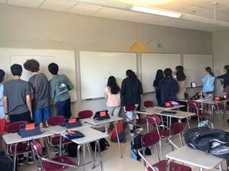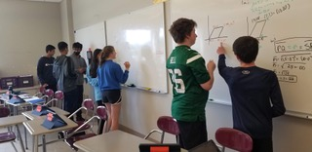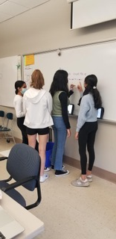

When asked why they liked working at the white boards, the students were overwhelmingly enthusiastic, with comments such as:

“I am able to get help from my peers if I don’t understand something and I don’t feel uncomfortable pressure to share my ideas in front of the class, since it is a group of 3 people.”

“If we are stuck on something, we can use our partners to help us. It helps me see the problem more visually- I like not doing it on the iPad.”

“And another really helpful thing was being able to look at others work to figure out where we made our mistakes…”

If the Thinking Classroom pilot proves to be invaluable to teaching Math, there may be consideration of other Thinking Classrooms for other subjects as well.

