The Daily Grind, a mobile Coffee Cart business for Special Education students
Shrewsbury High School’s Special Education Pre-Vocational program established The Daily Grind during the 2020-2021 school year as a way of connecting students and staff. It was a centrally located coffee shop set up in the High School media center, where staff could purchase coffee, snacks, and greeting cards. This year, thanks to the Colonial Fund, this business model was further enhanced through the purchase of a mobile coffee cart, which allows students to deliver coffee and tea to teachers and staff throughout the morning.
According to Meghan DeLeon, Director of High School Special Education, “The Shrewsbury High School Pre-Vocational program focuses on helping students gain real-life on the job training, hygiene skills, self-help skills, customer service skills as well as functional communication. Developing a coffee cart business creates a chance for faculty and staff to connect with students they might not have the opportunity to interact with during the school day.”
The students have been actively involved in the setup of the coffee cart program. When the first supplies arrived, students were busy assembling and taking inventory. Two students and their teacher also met with Mike Goldman, a representative from Good as Gold Coffee to learn more about the distribution process, cost and options available for wholesale purchase. Mr. Goldman was able to provide sample coffee, look at the coffee cart setup and offer suggestions like how to efficiently prepare iced tea/coffee, save costs with their sugar free flavor syrups and offer monthly memberships to consumers.
In addition to bringing students and staff together, the program offers many opportunities for collaboration between different groups of students. High School Computer Science students are working together to develop the “CafeApp” using XCode. At the start of the 2022-2023 school year staff can download the app to place their order. The app will also be utilized to track inventory of coffee and materials. Art students helped to design the logo. Middle School students from the Oak Middle School Design Lab, under the guidance of Jeremy Mularella, created and installed a vinyl sticker of the logo to put on the side of the cart (they made it using the laser cutter which was purchased with Colonial Fund money 3 years ago!). Kelli Mcsweeney and The Colonial Store at the High School donated hats and shirts with the Daily Grind logo for the student workers to wear. The Colonial Store will also selling special Daily Grind re-usable steel mugs for staff to purchase. It’s been a phenomenal group effort!
The Daily Grind invites all faculty and staff “to beat the daily grind, enjoy a cup and unwind”, and help students gain hands-on experience with running their own business.

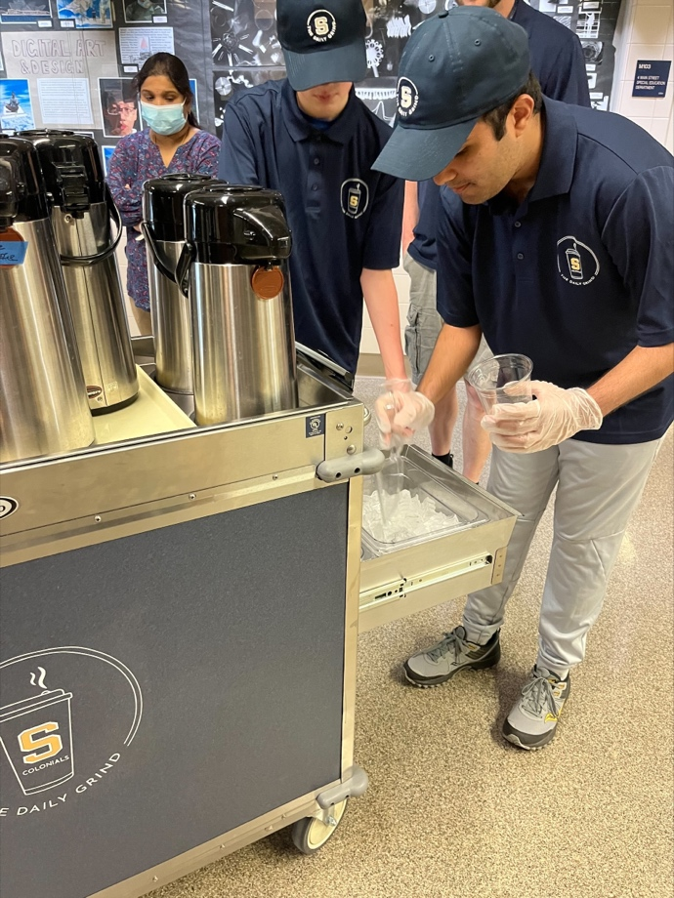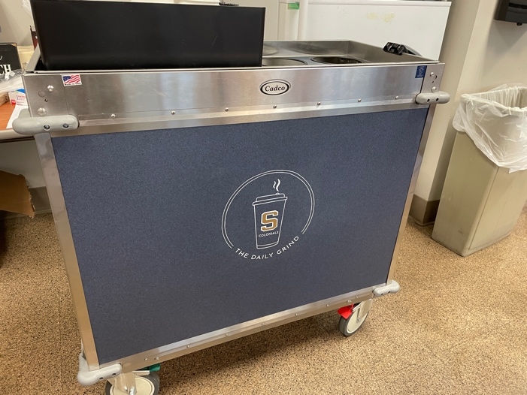
Working together to make iced coffee vinyl decal made by middle school students

Logo, created by Art students

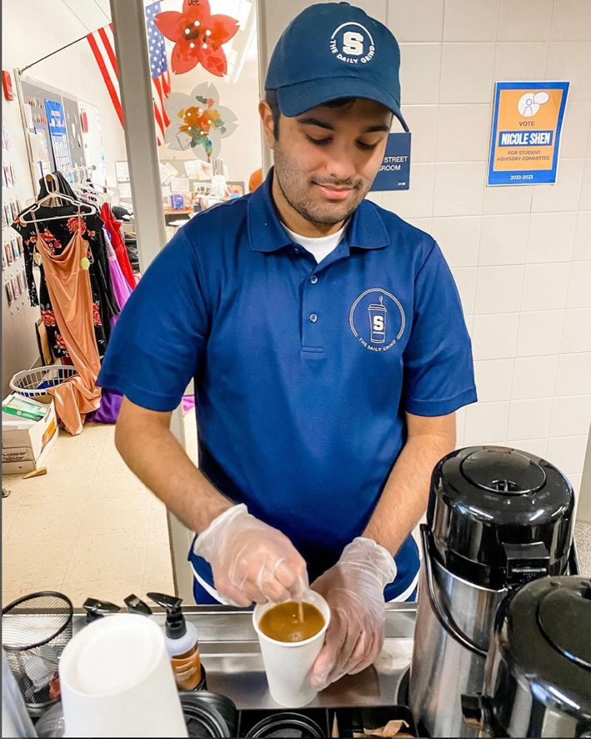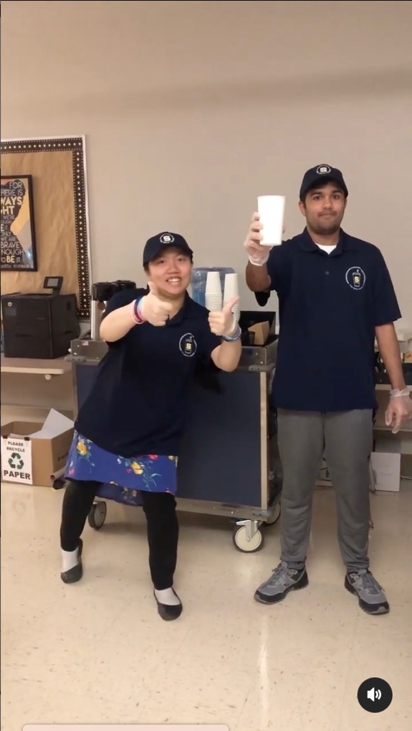
Styling in the custom shirt and hat! “To beat the daily grind, enjoy a cup and unwind!”

Become a Colonial Fund Supporter!

If you are inspired and excited by these projects, consider becoming a monthly donor to the Colonial Fund.

Make your monthly donation here: https://bit.ly/3NsbLMn or scan the QR code .

By giving just $10 per month, you would become an active part of the Daily Grind, by supplying a pound of coffee for the coffee cart each month. For a yearly donation of just $20 per month, you could inspire students to become better collaborators and communicators, by purchasing 1 white board for another Thinking Classroom.
Every amount makes a difference and we have future projects which could use your support. Your sustaining gift helps our teachers to be more creative and provides that extra special experience for your students. Please visit the Colonial Fund website (https://schools.shrewsburyma.gov/future/funded-projects) to see more of the incredible programs we have provided to your students this year.
Thank you for your support!

