Monday | Tuesday |  | Wednesday | Thursday | Friday
 |  |  | 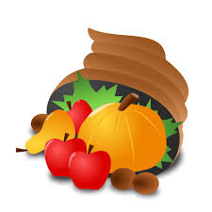 |  | 11/1  Chicken Nuggets  *Vegetarian Wrap /Baked Chips  Mashed Potato  Broccoli with Cheese Sauce  Dipping Sauces  Pears
4  Burger Bar and Toppings  *Veggie Burger  Baked Fries  Garlic Green Beans  Carrot Sticks and Hummus  Peaches | 5  Popcorn Chicken Bowl  Toasted Italian Sub with Baked Chips  Mashed Potato  Corn  Gravy  Carrot Sticks and Ranch Dip  Wheat Roll  Sliced Pears |  | 6  * Monti's Pizza  Chef's Choice  Baked Sweet Potato Fries  Peas  Tossed Salad  Strawberries | 7  Chicken Penne Casserole  Italian Sub with  Baked Chips  Steamed Broccoli  Caesar Salad  Roll  Watermelon | 8  *Italian Grill Cheese  Toasted Meatball Sub  Macaroni Salad  Tomato Soup  Mixed Fruit
11  No School | 12  No School |  | 13  * Manti's Pizza  Cubano Sandwich  Baked Fries  Green Beans  Caesar Salad  Strawberries | 14  Chicken Nuggets  Grilled Chicken BLT Sub  Mashed Potato  Hummus and Celery Sticks  Steamed Carrots  Mixed Berries | 15  Breakfast for Lunch( Eggs,* Bacon, French Toast Sticks and Hash Browns)  Turkey Cheese Sub with Goldfish  Carrot Sticks and Ranch  Yogurt  Mixed Fruit
18  Chicken Patty  *Garden Burger  Baked Fries  Steamed Broccoli  Garden Salad  Apples | 19  Caesar Salad Bar*  Chicken Patty Sandwich with  Baked Chips  Broccoli  Garlic Knot Roll  Apple Sauce Cups |  | 20  * Monti's Pizza  Chef's Choice  Baked Fries  Peas  Celery Sticks and Ranch  Tossed Salad  Strawberries | 21  *Mozzarella Sticks with  Marinara Sauce  Buffalo Chicken Patty Sandwich  Baked Spiral Fries  Corn  Roll  Pears | 22  Pasta with Meat or Marinara Sauce*  Toasted Meatball Sub  Macaroni Salad  Tomato Soup  Caesar Salad  Mixed Fruit
25  Twin Dogs  *Garden Burger  Baked Fries  Baked Maple Beans  Mixed Fruit | 26  *Macaroni and Cheese Bar  Chicken Patty Sandwich  Steamed Broccoli  Garden Salad  Fresh Apples |  | 27  No School | 28  No School | 29  No School
Lunch $3.50  Reduced Lunch$.40  Milk/Bottled Water/Juice $.70  Check - Food Service News Letter for monthly promos  http://schools.shrewsburyma.gov/foodsvc/index.cfm  Please call the Cafeteria Manager at your child's school if you have questions about food ingredients or allergens. |  |  | All Lunches include: 1 Milk, 1 Juice, Grains, Protein Selections and Fruit and Vegetable Bars. Additionally Served Daily: *Peanut Butter Sandwiches, Assorted Sandwiches, *Breakfast Bags (Cereal, Muffin or Bagel, Yogurt and Fruit) Assorted Grab and Go Meals and Daily Meal Specials. |  | 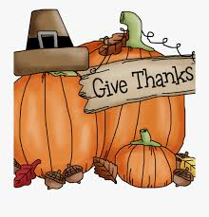
USDA is an equal opportunity provider and employer

