Calvin Coolidge Reading Incentive Program
Reading Recording Sheet
Name:________________________________ Teacher_________________ Sheet# ___
Please color or cross off each book below for every 20 minutes that you read or are read to.
Once your sheet is filled, have it signed and return it to your teacher.

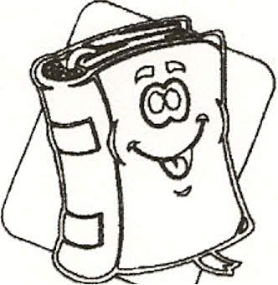  20 min | 20 min | 20 min | 20 min | 20 min
20 min | 20 min | 20 min | 20 min | 20 min

Great job! Remember to keep reading and bring your completed sheets back to school for credit! For more sheets, you can go to; http://schools.shrewsburyma.gov/egov/docs/1255430302_925933.pdf - for 20 minute recording sheets. Remember you need to complete at least ten sheets to receive a medal in May!

Parent or Teacher's Signature:___________________________________________ Date:____________

