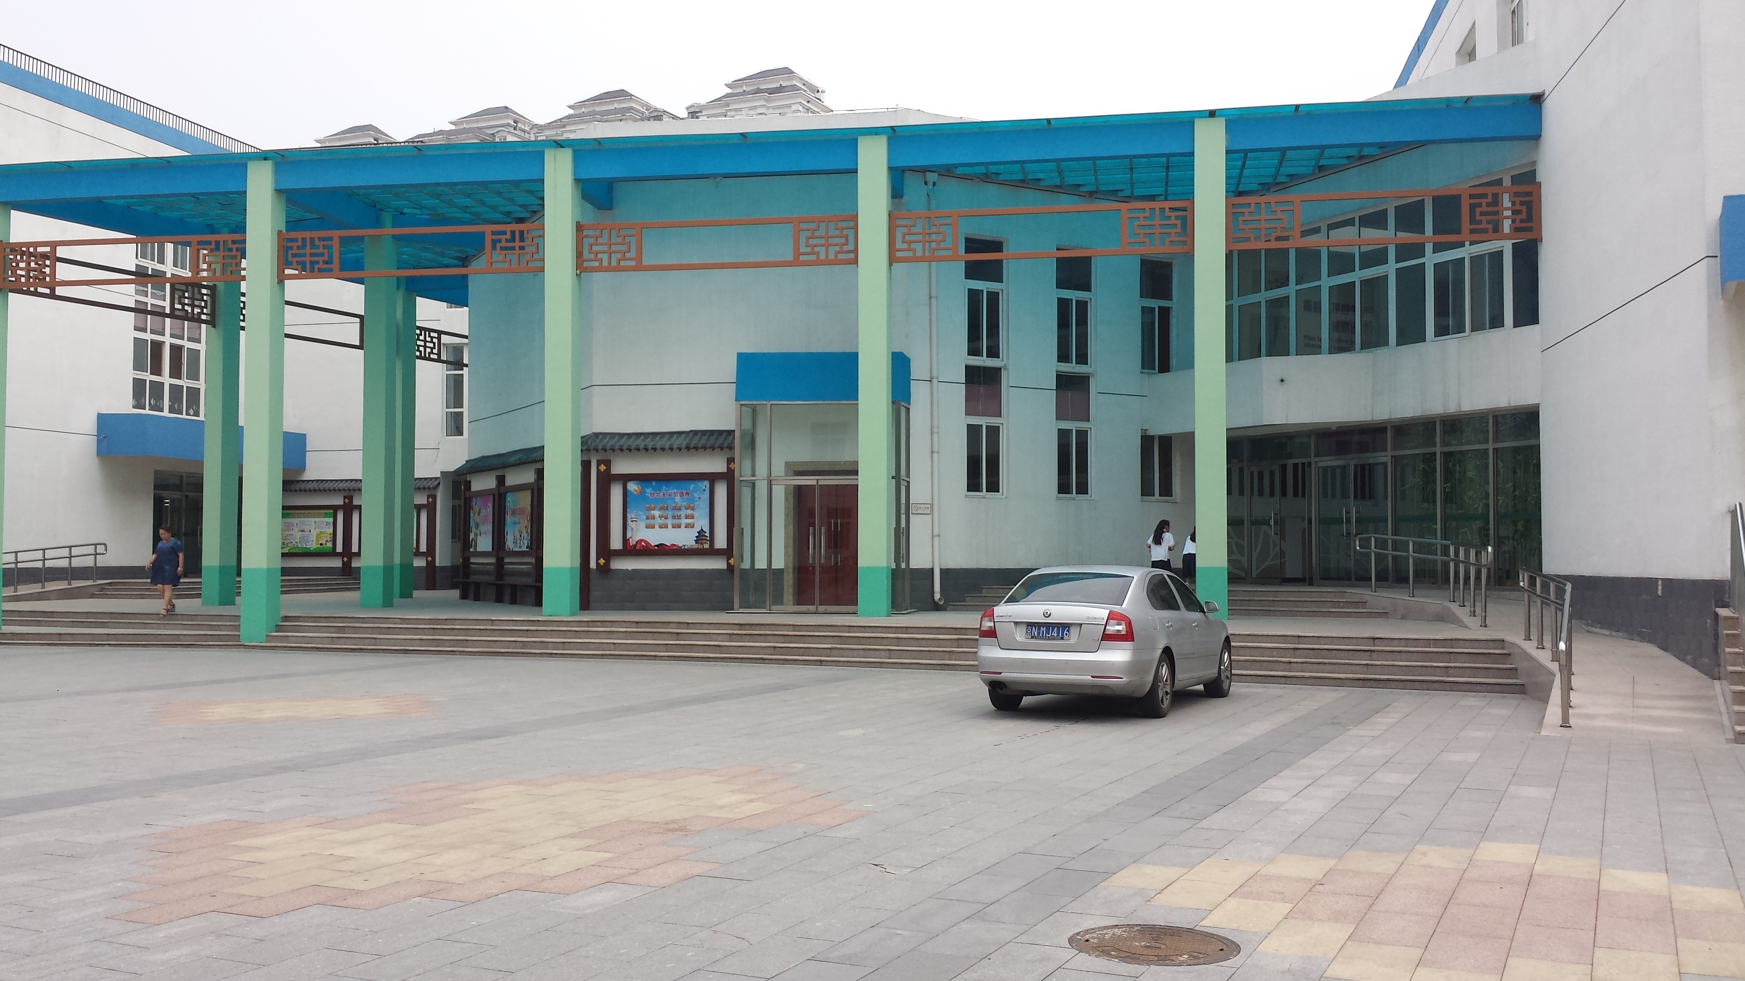[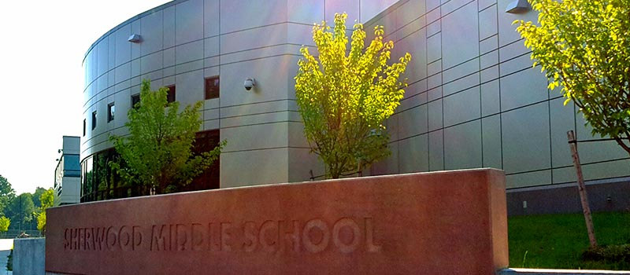](https://www.google.com/url?sa=i&rct=j&q=&esrc=s&source=images&cd=&ved=0ahUKEwjGyvSy-MbSAhWB7yYKHYKbCHsQjRwIBw&url=http://schools.shrewsburyma.gov/sherwood/&psig=AFQjCNFkMA4Xe1cj1RjKS6HlIoO15c1K2w&ust=1489063613047310)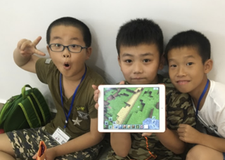

Helpful Tips

1. Students may be jet lagged. A short nap upon arrival will help students adjust to the time difference.
2. Set rules and expectations as soon as possible. Make a list of expectations you would like students to follow. Use pictures if possible.
3. Treat your host student as you would like your child to be treated.
4. Upon arrival give a tour of your house and show them how things work (faucet, toilet, etc.).
5. Let students know schedule ahead of time so they know what to expect and when.
6. Time difference will make it challenging for students to communicate with family at home. Encourage them to set a regular time to communicate that works for everyone.
7. Enjoy and thank you! This will be a great experience for you and your family!

Welcome Host Families

Host Family Information Night

3/13/17

3/21 – Students arrive in Boston

3/22 – Students meet host families at

Sherwood around 5:00 PM

3/23 – ½ day at Sherwood

3/24 – Full day at Sherwood

- School Dance - 6:30 PM

3/25-3/26 - Weekend with host family

3/27 – ½ day at Sherwood

3/28-3/29 –Students in NYC

3/30 – Full day at Sherwood – Farewell

Party at Sherwood 6:00 PM

Important Dates