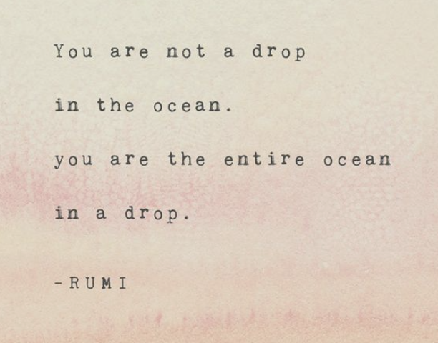
6 Purple Materials Request
2023-2024
Dear Families,
Welcome to the 6 Purple- part of the Good Vibe Tribe. We are excited to meet you in the fall and are eagerly planning our special time together. Please find the attached materials list. While no one is expected to send in shared items, we deeply appreciate any of the items you can provide. We will be expressing our unique perspectives in academic and artistic ways this year, so the art supplies and cleaning supplies come in handy! Each child and family are unique, and we will strive for a strong collective together.

We try to keep supplies to a minimum. But each child will want the typical pencil pouch, backpack, and lunchbox in addition to the items on this list.

ELA/SS
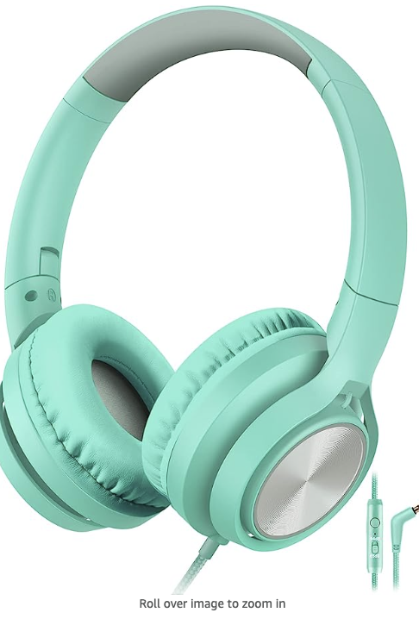
- Headphones that have a microphone (not earbuds) labeled with first and last names.
Something like this will work for about $9.95 (link to Amazon here)
- 1 composition notebook (please NOT spiral bound)
- 1 black, heavy-duty folder
- 1 purple heavy-duty folder
- Fast writing pens
Math/Sci
- Dry-erase whiteboard marker(s)
- Pencil(s)
- 1 composition notebook

Both: 1 purple shirt to wear for school events and decorate
1 heavy-duty folder (Color of your choice)

Optional Shared Items:
Please consider donating the following items that students will be using in all classes, for academics, and for, social-emotional learning, projects, and belonging art.
- Lined paper
- Pencils
- Heavy-weight watercolor paper
- Watercolor paints
- Paint brushes
- Markers
- bright/fun dry-erase markers
- Glue sticks
- Cleaning wipes
- Paper towels
- Tissues
- Magic Erasers (awesome for whiteboards, desks, and oops moments)

